Crypto Currency Analysis Report

The cryptos were analyzed to check if they can be classified into various cluster.

Of the 1252 crypto currencies only 532 crypto currencies were selected based on the following criteria

* Currency was traded
* Currency had a positive value for total coins mined
* Currencies with null values for total coins mined were discarded

The PCA yielded 74 principal component columns with a 90% of explained variance

Using TSNE on the PCA columns did not result in a very clear set of cluster

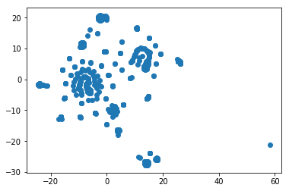

The Kmeans mechanism for identifying optimum number clusters was used to accurately identify the the number of clusters. The elbow plot seems to suggest that the crypto currencies can be classified into **8 clusters**

